- Create a Google Business Profile for a fictional local café in your city, filling out business name, address, phone number, hours, and at least one photo. Take a screenshot of the completed profile page.
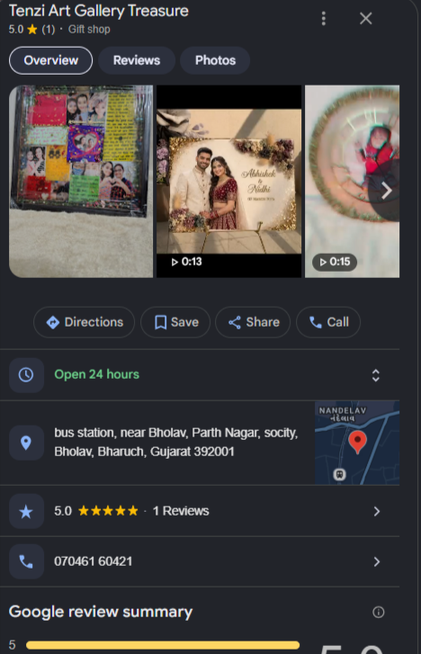
- List the NAP (Name, Address, Phone) details for 3 popular restaurants in your area as shown on Google Maps, Zomato, and their official website. Identify any inconsistencies between the platforms.<br><br><em><strong>Hint:</strong> Consistent NAP across platforms helps improve local SEO ranking.</em>
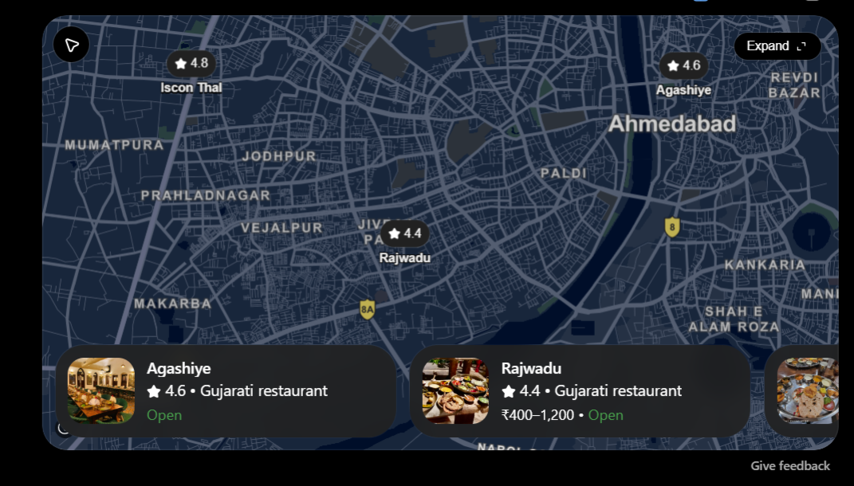
- Find and record 5 local citation websites (like Justdial, Sulekha, IndiaMart, Yellow Pages, etc.) where a local business can submit its details for better local SEO. For each, note what business information is required to submit.
Citation Website | Business Information Usually Required
Justdial | Business name, address, phone number, business hours, category, photos, and services/products. (Just Dial)
Sulekha | Business name, location/address, phone number, category, services, business description, and contact details. (MapLift)
IndiaMART | Business name, business type, contact number, address/location, products/services, category, website, and business description. (DataGators)
Yellow Pages India | Business name, address, phone number, category, website, description, and other contact/business details. (MapLift)
TradeIndia | Company/business name, contact person, phone/email, address, products/services, category, and company description. (Eravue)

- Pick a local business (not a hospital or library) and use a free local rank tracking tool (such as BrightLocal’s Local Search Results Checker or Whitespark’s Local Rank Tracker demo) to check its ranking for the keyword 'pizza near me' in your city. Write down the business’s position and the date you checked.<br><br><em><strong>Hint:</strong> Many tools offer a free trial or demo mode—no need to pay.</em>
